1.Триггер

Create trigger TRIG1 after insert on vladelec_mag for each row update vladelec_mag set id=’1’ where id_x=’2’;

Create trigger TRIG2 before update on magaz for each row insert into magaz values (‘ID’,’nomer’,’nazvanie’,’adres’,’telephone’)

Create trigger TRIG3 after delite on postavshik for each row update vladelec_mag set id=’1’ where fio=’Bugaev_SV’;

2.Функции

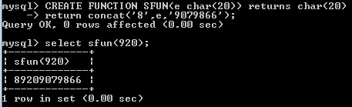

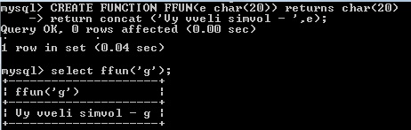

3.Процедуры

create procedure PROC1 (in e int)

begin  
select *from vladelec_mag where id=e

End

//

Вызов процедуры call proc1(@1)